Name : S.Logeshwari Reg No:731621205029

Dept : Information Technology Tittle : SQL Lab Practice

College : KSR Institute for Engineering and Technology

Create Table - I ( CLIENT_MASTER ):

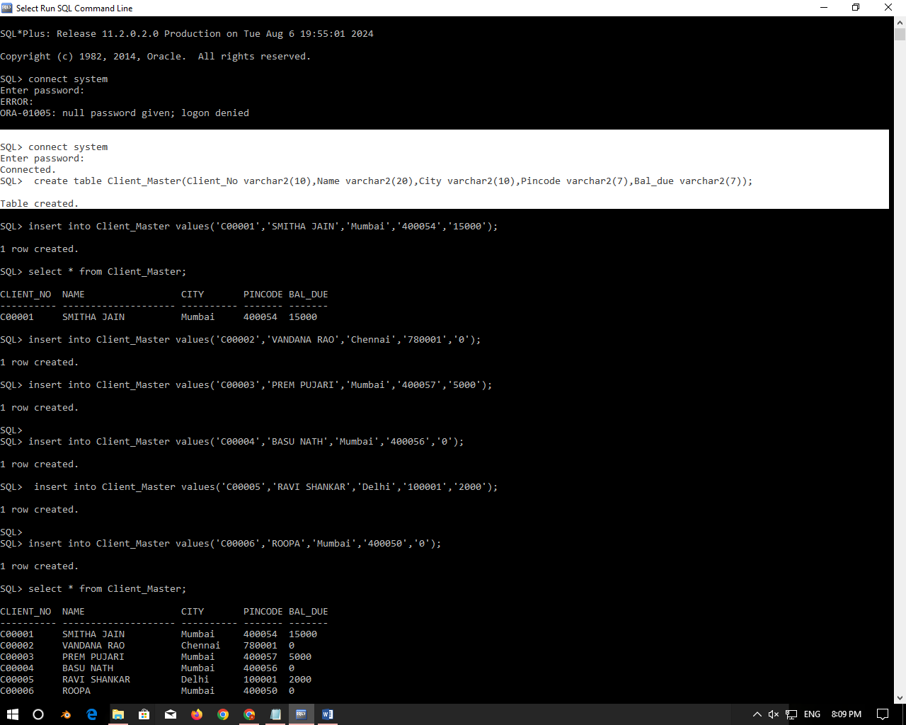

Inserting values :

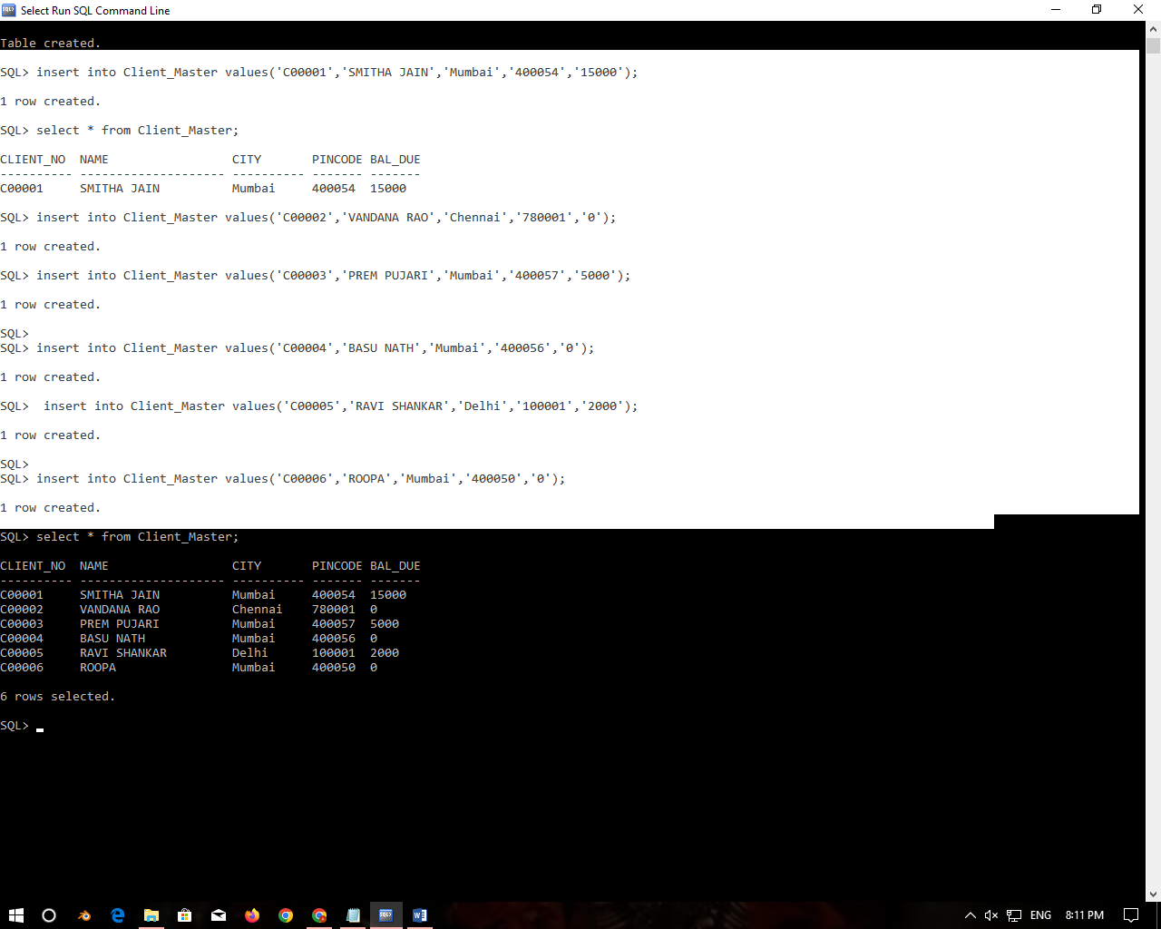

Display Table:

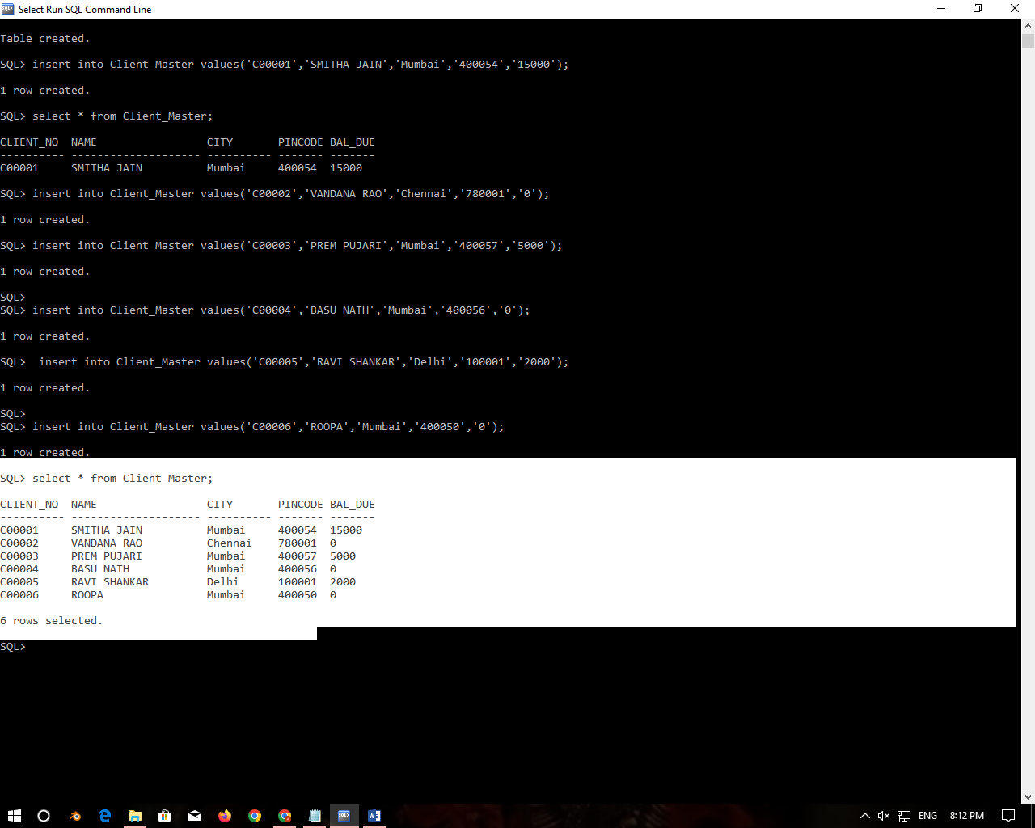

Table - II ( SALE_ORDER )

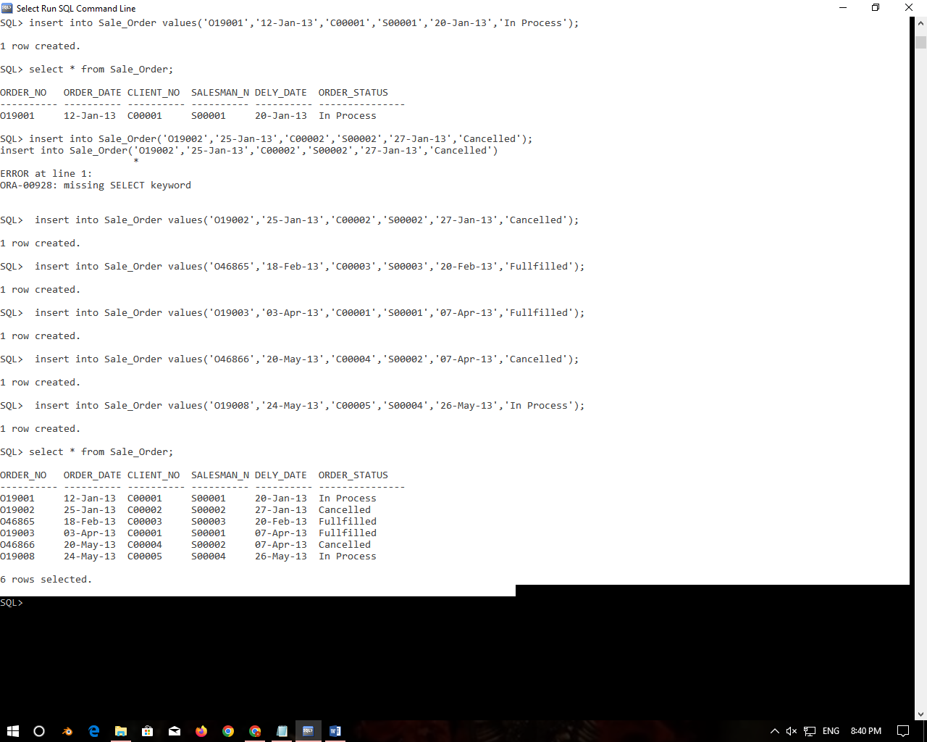

|  |  |
| --- | --- |
| **Write SQL commands for the following:** | |
| **1.** | **List all details from the client_master table for clients whose Bal_due = 0.** |

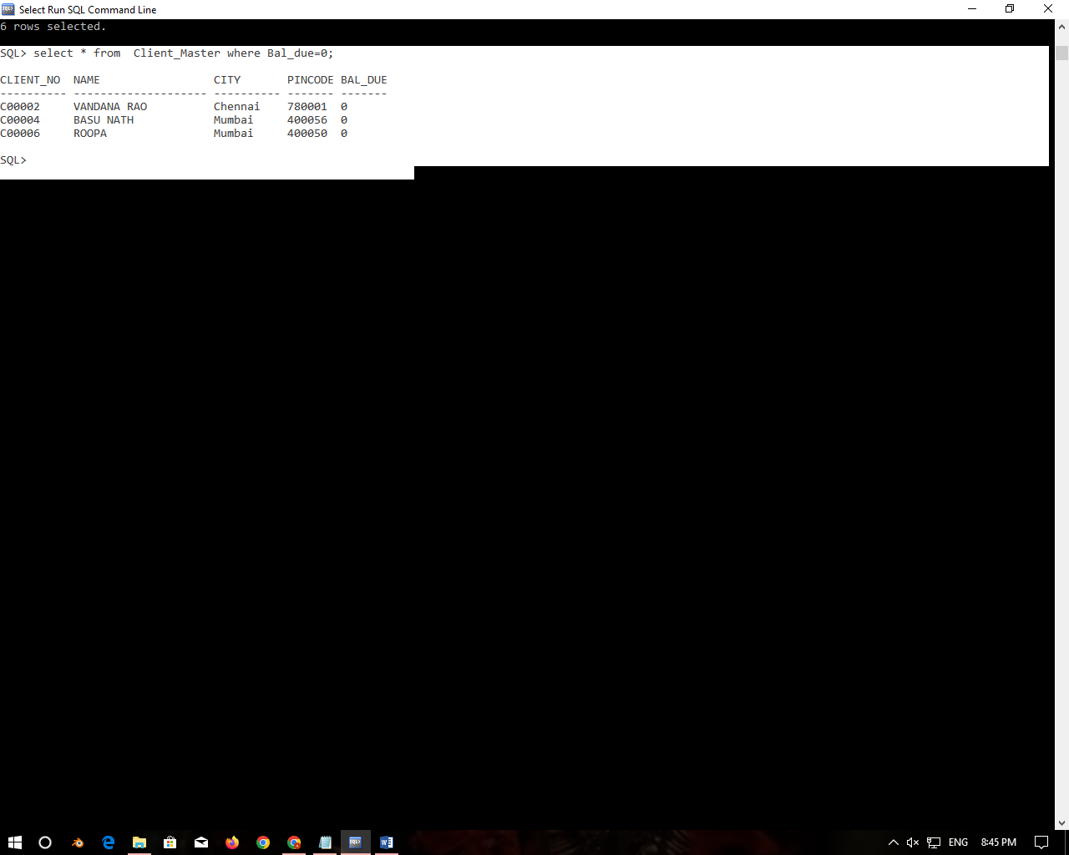

|  |  |
| --- | --- |
| **2.** | **Update table client_master, Change city of Client_no C00004 to Jaipur.** |

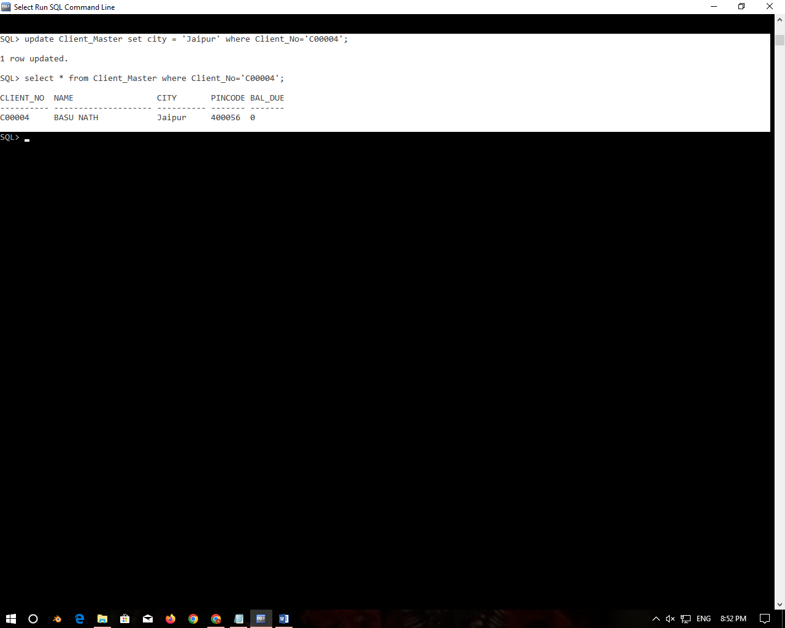

|  |  |
| --- | --- |
| **3.** | **Retrieve records of clients residing in Mumbai.** |

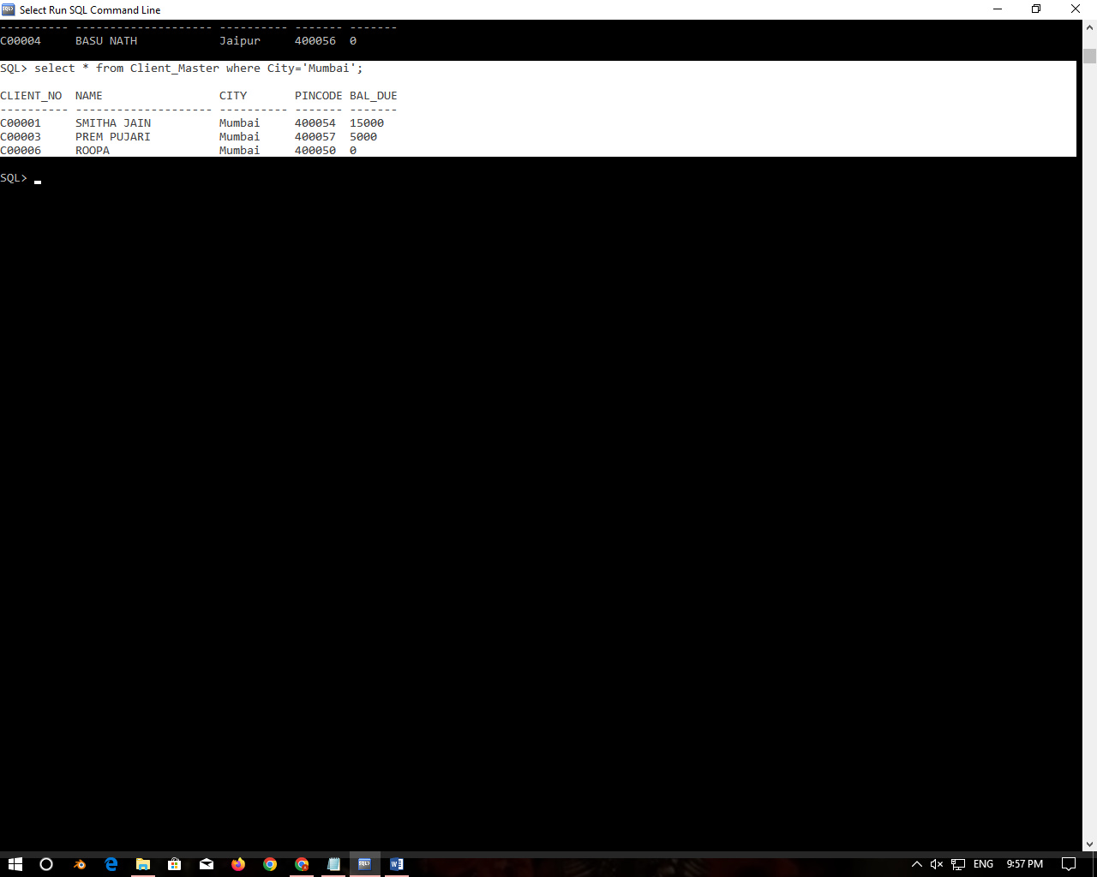

|  |  |
| --- | --- |
| **4.** | **Find the name and address of customer who has placed Order_no 'O19003' and 'O19002' respectively.** |

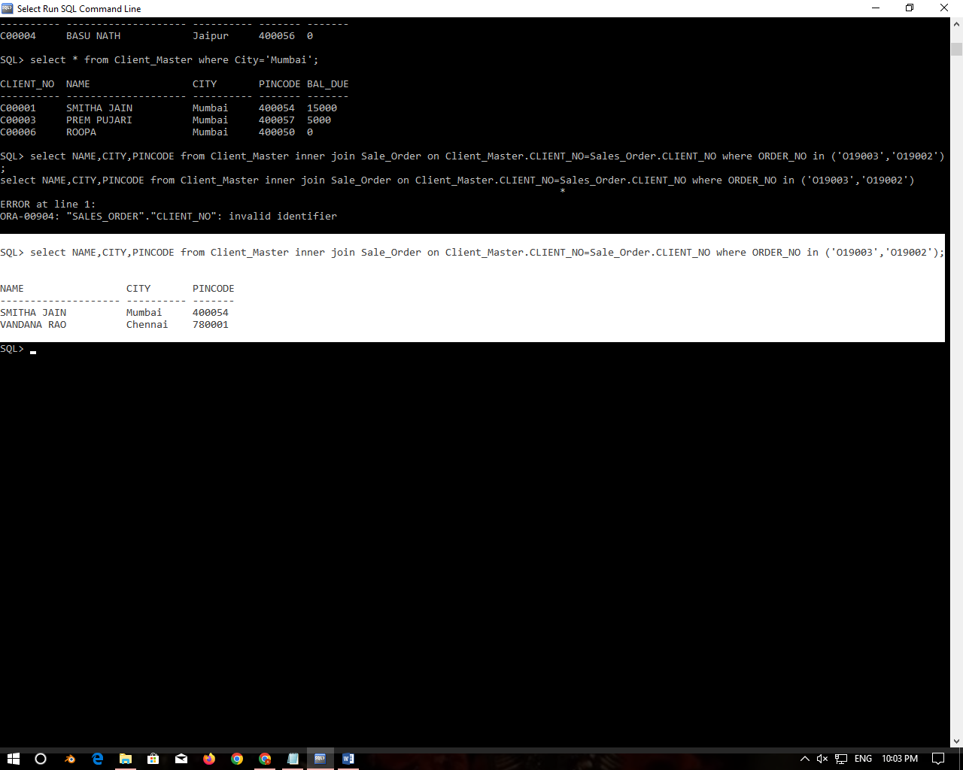

|  |  |
| --- | --- |
| **5.** | **Construct English like sentence from the table client_master ({Customer name} live in the city of {city}).** |

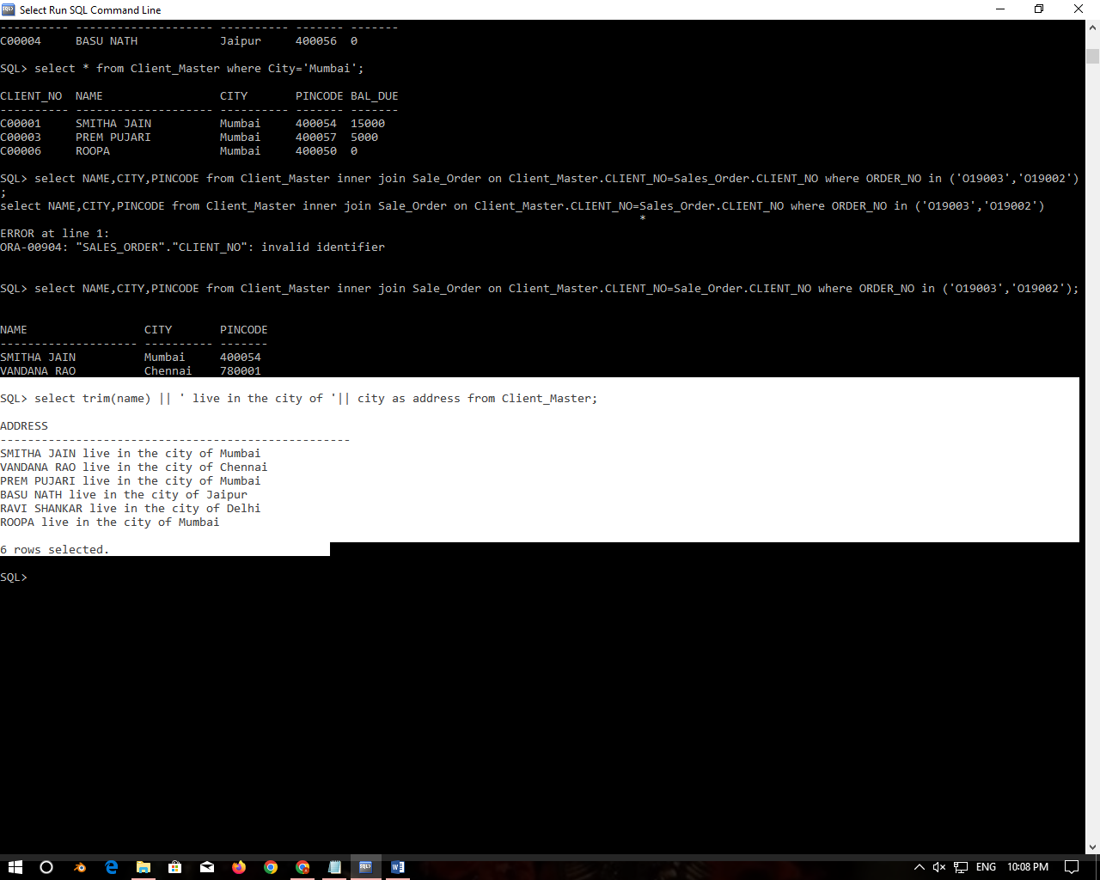

|  |  |
| --- | --- |
| **6.** | **List the client_no, name, city and pincode of clients whose Order_status is "In process".** |

